Teams External & Guest access.

To allow users to chat to external users there are a couple of settings that need to be set.

This is done per user….

Firstly, the compliance needs to be on.

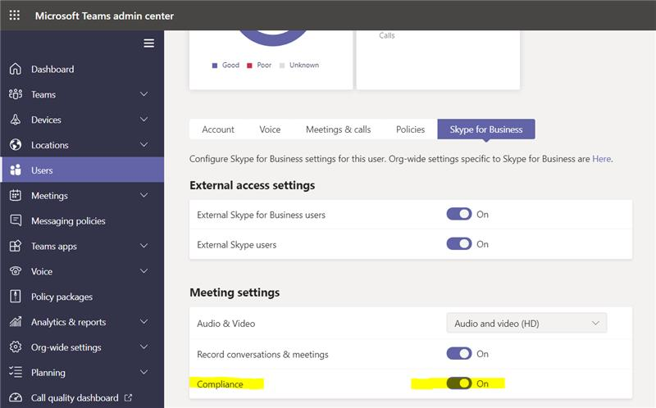

Then the user needs to be set to Teams Only

This will allow more functions like presence.

